Dorothy Michaels

Core: Gotham: July 2013

Professors Mike and Damian

MOLLOY COLLEGE

When I think of Coney Island I think of Nunley’s, The Wonder Wheel, and Cyclone. Because of the Cyclone, The Tornado and the Thunderbolt, Coney Island is known as the grandfather of the rollercoasters. I can still taste the hot dogs from Nathan’s and homemade potato knish’s bought from the Russian lady walking on the beach. I think of throngs of people walking on the boardwalk, lying on the beach, playing carnival games, and joyfully laughing and screaming on the rides.

There are many versions as to how Coney Island’s name was founded. It is said that when the Dutch settled in Coney Island they named it Konijn Eiland, (Rabbit Island), for the rabbits found there (von Pressentin Wright 2008). The Dutch called Coney Island "Konijn Hok," (the rabbit's hutch or breeding place). It is said that this was a pun on the fact that genuine rabbits or coneys shared the beach with the Canarsie Indians. The Canarsie Indians lived on the island until 1655 when they were destroyed by the Mohawk Indians. According to Stanton, Konijn Hok became Conyne Island, while another suggests the name comes from the Coyne family. The Coyne’s were a Dutch family who lived on the Island (Coney Island-The Early Years).

Somewhere between 1823 and 1829 the Coney Island Road and Bridge Company was established. They built a shell road that crossed a creek, thus conjoining the mainland to the beach. The first hotel was built in this timeline as well and named the Coney Island House. This hotel was the beginning of Coney Island’s summer resorts (Stanton). Tourism then began to flourish and investors built more hotels. Ferries took a half a day to travel from Manhattan to Gravesend and were filled with wealthy businessmen, their families, politicians and eventually those who were curious. By 1846 gambling, heavy drinking and fighting became common practice in Coney Island (Stanton).

In 1865, Peter Tilyou and his family built the Surf House. This became the first bath house on Coney Island’s shore. Tilyou offered 0.5 cent Bavarian lager, 0.25 bathing suit rentals, and gave away a free bowl of clam chowder with each rental (Stanton). Ocean Swimming was not a common practice in 1860. People at that time were afraid they might lose essential body salts. A medical expert named Dr. Durant was consulted and taught the people that bathing dress should be made of woolen fabric as it retains the heat and prevents rapid evaporation in the body. He further suggested that maroon and blue are the proper colors as they resist the corrosive and bleaching effects of salt water (Stanton). Brown, blue, and gray twilled flannels were also recommended as well as hats and shoes to protect against the sun and the crabs.

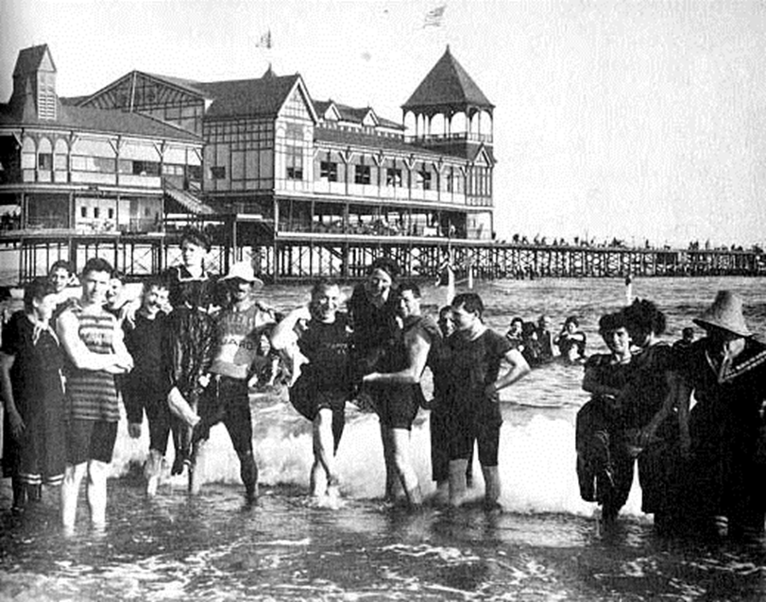  
Stanton: Bathers in the 1860’s by Coney Island piers.

The first hot dog was actually made in Germany during the 1600s and was called a “dachshund” or “little dog.” These early hot dogs were actually sausages. Charles Feltman slenderized the sausage and placed it in a bun calling it a hotdog during the late 1860s and early 1870s. Charles Feltman subleased a small plot of land by the shore and sold his hotdogs. He earned enough money from his hotdogs to build a 100 foot long Iron Pier in 1878. The pier had space for 1200 bath lockers, various games, and food stands. Two years later, he installed a Looff carousel in his beer garden. Feltman’s businesses continued to grow and prosper allowing him to build a ballroom large enough for 3000 dancers and a piazza for 5000 onlookers (Stanton).

[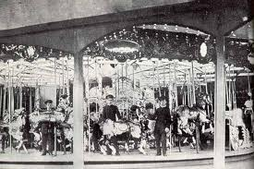](http://www.google.com/imgres?q=charles+feltmans+looff+carosel&um=1&hl=en&sa=N&qscrl=1&nord=1&rlz=1T4IRFC_enUS382US382&biw=1280&bih=566&tbm=isch&tbnid=V8yHx0lOOryi-M:&imgrefurl=http://www.westland.net/coneyisland/articles/carousellist.htm&docid=kuBJ4KUIA3p8cM&imgurl=http://www.westland.net/coneyisland/articles/images/con-feltmancarousel.jpg&w=537&h=357&ei=ydazT5SXEoi16AHb2eGBBg&zoom=1&iact=hc&vpx=789&vpy=205&dur=4744&hovh=183&hovw=275&tx=163&ty=101&sig=111515289271672845935&page=1&tbnh=131&tbnw=197&start=0&ndsp=10&ved=1t:429,r:3,s:0,i:82)

Stanton: Feltman’s Carousel

Coney Island’s first carousel was supplied by William Vanderveer in 1875. The carousel was carved by Charles Looff and installed by Vanderveer to provide amusement for his guests. In 1876, Ocean Parkway was built from Prospect Park to the ocean. Ocean Parkway was made of two gravel roads 25 feet wide and landscaped with trees and shrubs on each side (Stanton).



Stanton: Ocean Parkway 1876

Fred Thompson, nicknamed “the kid” and his partner Dunnavant designed a new amusement ride called “A Trip to the Moon” for Buffalo’s Pan American midway in 1900. The spaceship design for the amusement ride was called Luna, which turned out to be a major success. While in Buffalo, Fred Thompson formed a new partnership with Skip Dundy, together they founded Coney Island’s Luna Park in 1903. George Tilyou met Thompson in Buffalo and persuaded him to come to Coney Island to build “A Trip to the Moon” in his Steeplechase Park (Register, 2001).

Luna Park’s opening day was May 16th, 1903. Hand carved Roman chariots stood at the entrance serving as box offices. Women in black evening gowns wearing red hats were in the chariots. Scenic illusions of 20,000 leagues under the sea and War of the Worlds were present. The ride “A trip to the Moon” premiered. On the first night as many as 60,000 people visited Luna Park (Register, 2001).

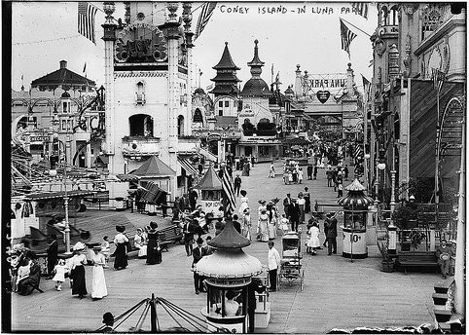

Register, Luna Park

Fred Thompson was the designer, part owner and manager of Luna Park and was a constant presence within the park. Fred Thompson could be seen swirling around on the rides he designed and built. Thompson marketed a different view of life, bright lights, adult toys and promoting “go out and have fun”. Many have tried to imitate Luna Park, their success was mediocre at best (Register, 2001). The events of the early 1800s to the early 1900s helped to shape what Coney Island is today (Coney Island-Early Years).

Coney Island today still hosts an array of different events to keep the season going. On June 2, 2013, The Circus Sideshow began continuous hourly performances from 1:00pm-8:00pm daily. On June 22, 2013, the 31st anniversary of the Mermaid Parade began at 1208 Surf Avenue. Fireworks are presented every Friday evening from the last Friday in June until Labor Day. The 13th annual Coney Island film festival will be presented September 21-22, 2013.

Hurricane Sandy devastated Coney Island when it landed on shore October 29, 2012. The famous Wonder Wheel and Luna Park are once again operational. Nathan’s re-opened on Memorial Day 2013 and the Parachute was re-lit June, 24, 2013. The New York Aquarium in Coney Island, which was also devastated during Hurricane Sandy; sustaining millions of dollars in damages, has partially re-opened as of Saturday May 25, 2013.

"Coney Island." *Coney Island*. Coney islands resident not for profit arts organization, May, 2012.

Web. 16 May 2012. <www.coneyisland.com>.

Register, Woody. *Fred Thompson and the Rise of American Amusements’*. Cary, North Carolina:

Oxford University Press, 2001.

Stanton, Jeffrey. "Coney Island - Early Years." *WestLines.net*. N.p., 19 N. Web. 16 May 2012.

<http://www.westland.net/coneyisland/articles/earlyhistory.htm>.

von Pressentin Wright, Carol. *Blue Guide New York*. 4th. Somerset: Blue Guides Limited, 2008.

492.