BODACIOUS BROOKLYN

Brooklyn, by far, is my favorite borough; once again Professors Mike and Damian brought me to places I have not yet been to. This was a dreary, rainy, cool, cloudy, fun, but nice day. There was nothing about Bodacious Brooklyn that was drab or boring.
Originally Brooklyn was settled by the Dutch. England attempted to overtake Brooklyn, but was negated due to George Washington’s mastery for moving troops. Washington defeated the English on August 29, 1776.

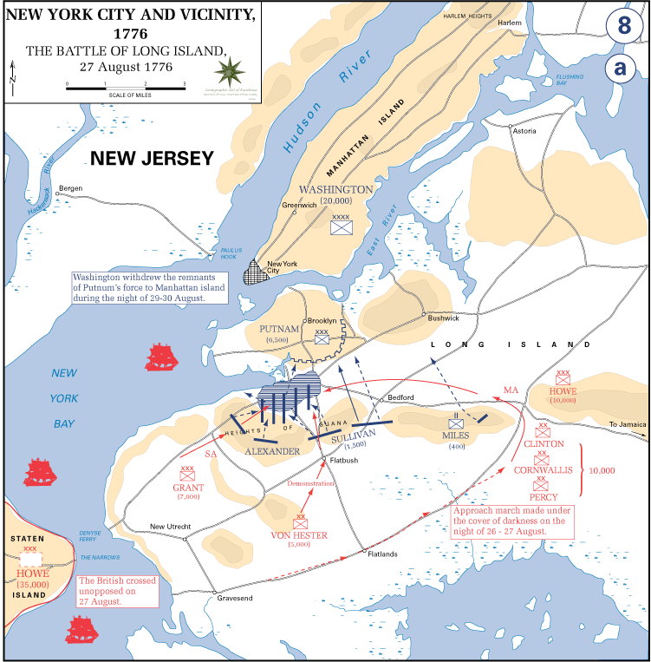
The blue guide suggests that Washington brought his troops of 9500, from Brooklyn Heights to Manhattan Island’s Fulton Street Ferry Landing. He accomplished this via fishermen under the cloak of dense fog.
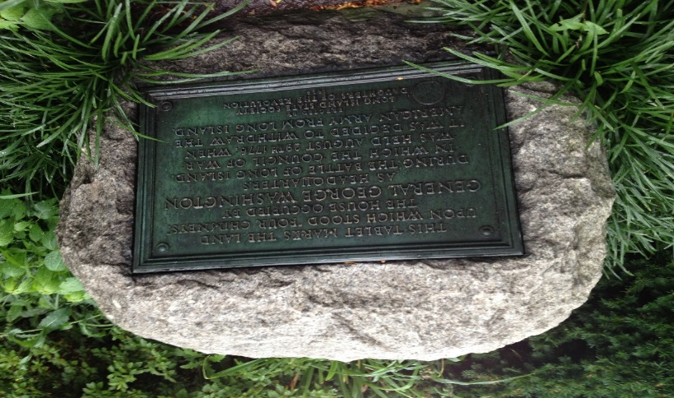
Brooklyn became a hot spot due to Coney Island’s Steeple Chase Park in 1897 and Luna Park in 1903 ( Blue Guide, p492). As a student, I began my journey on the D line from Penn Station to Coney Island’s Surf Avenue; the trip was uneventful and I was able to speak with my friend Paulette and Mike my professor / tour guide without interruption.
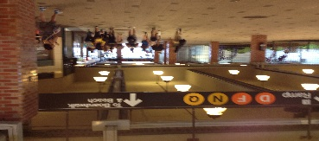

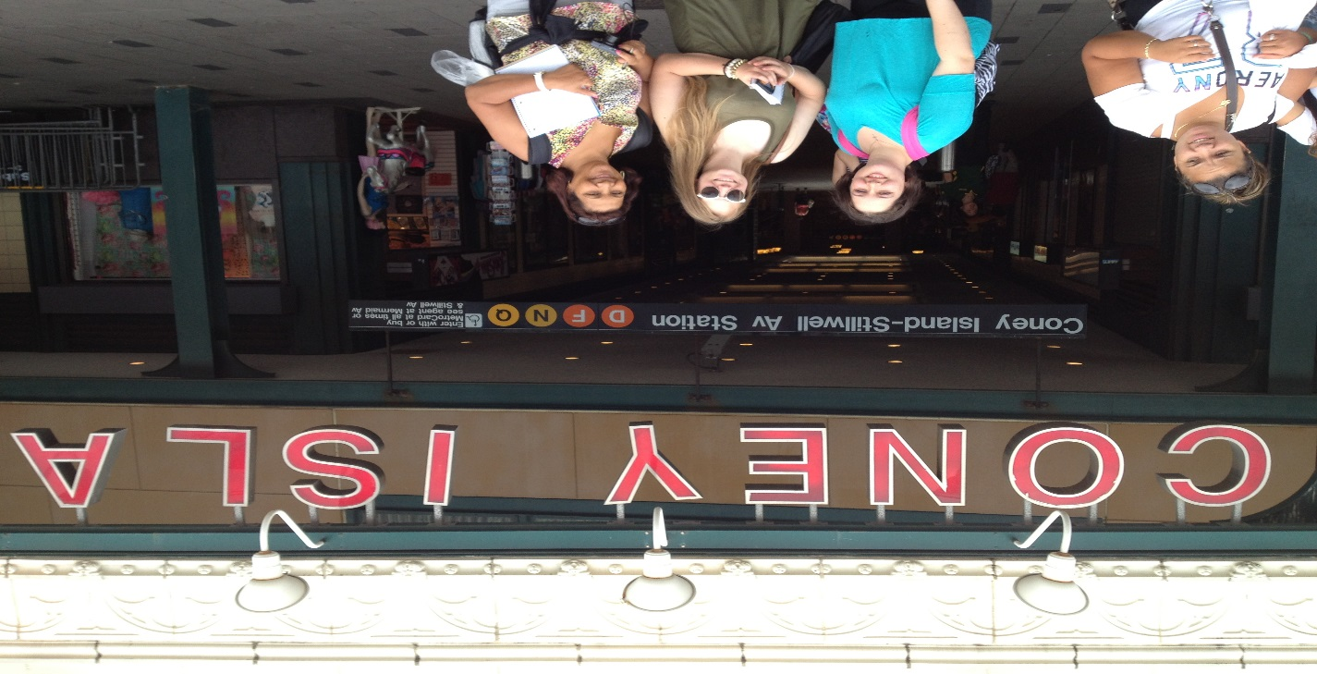
Coney Island, in the 1970s and 1980s was considered a slum; visitors needed to keep an extra diligent eye for deceptive people targeting easy prey. In the late 1980s to early 1990s gentrification began in the area. Young starving artists wanting the Brooklyn cost of living and the ambiance of the city, choose Brooklyn’s coast line as a place to hang their hats. Brooklyn’s Coney Island brings people from all over the world to experience its rides, games and beaches.
Coney Island was sold in 2006 by the Albert family to Thor Equities; prior to the purchase of the park Thor Equities had already bought properties surrounding the area. They spent one hundred million dollars on those purchases.
During my visit to the park I noticed new rides and a cleaner area; there were many people on the beach and boardwalk having fun. I sat on a bench and enjoyed a hotdog with crinkle cut fries from Nathan’s.
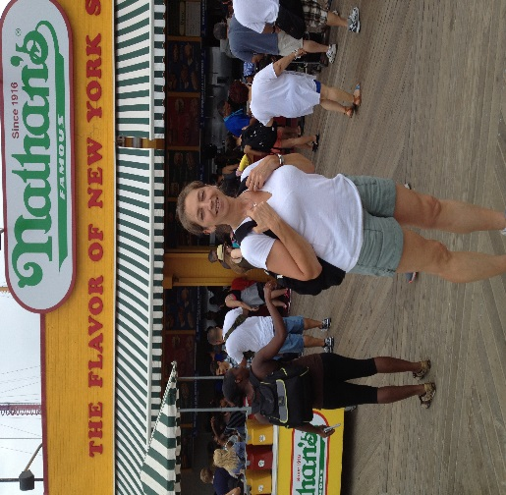
From Coney Island we took the F train to Brooklyn Heights stopping at Myrtle Avenue and Jay Street to visit the Transit Museum. The Transit Museum was built in 1936 in the vision of being the first Second Avenue stop; the problem with this is that the Second Avenue Tunnel is still in the process of being built. The stop is Court Street; from 1936 to 1946 the station was used to carry people from Court Street to Hoyt/Schermerhorn Streets using the HH trains. Our guide for the transit museum was Catherine, she was enthusiastic and informative; she explained the city’s population size was increasing dramatically in the 1800s and the mode of transportation was primarily horse drawn carriages. This created unhealthy living conditions for people. Due to the blizzard of 1888, NYC began to put its power lines and trains underground. The storm knocked out transportation and communication, as well as killing over two hundred people in NYC alone.
Catherine explained how the stations were built in the late 1800s and early 1900s using steel, stone and backbone.
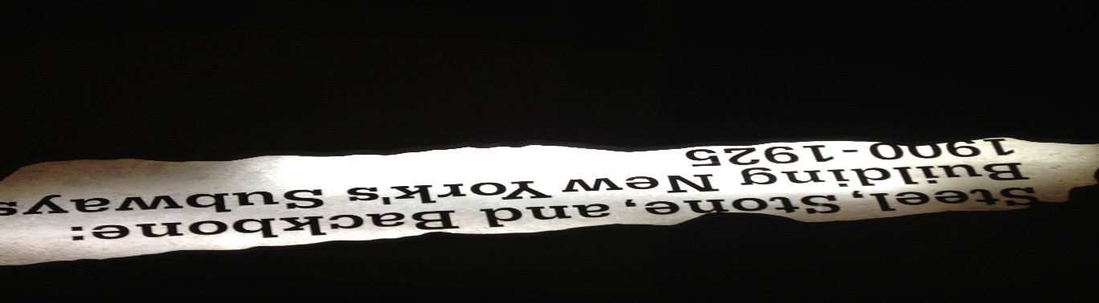
Pick axes, shovels and man’s might were used. The common nationalities of the men competing for the jobs were Irish, Italian and Afro-American. Spoils carts removed the debris: and sand hogs were built underneath the river bed.
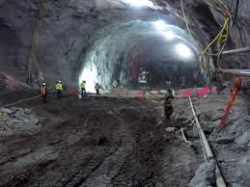Sand hogs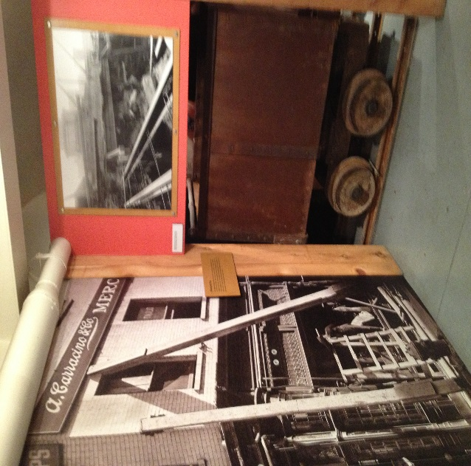Spoils cart
The sandhogs, as Catherine explained, had the most dangerous job and were of the lowest paid in the late 1800s – early 1900s; today they are amongst the highest paying jobs due to the dangers the men encounter. Sandhogs could only work two-three hours at a time due to the heat and pressure encountered under the river bed. The men’s exposure to nitrous oxide held the possibility of contracting Caissons Disease, also known as the Bends and Diver’s Disease. Caissons Disease is caused by breathing decompressed air; it is characterized by joint pain, respiratory issues and possibly skin lesions. The men in the late 1800s early 1900s were not unionized; therefore they lost their jobs if they contracted the disease.
While in the museum, I was given ample time to view the many interactive trains provided by the Metropolitan Transit Association (MTA). What I found most interesting was the electric trains and how they were provided with power to run. I do not pretend to know any more about electric other than, I plug it in and it works. This was intriguing because these trains, built underground with men risking their lives to feed their families ran with electricity. I find this to be amazing because in the 1970s and early 1980s the MTA still ran the LIRR above ground with diesel trains; the technology was there 100 years earlier. The LIRR was built in 1834, on September 8, 2010 the LIRR’s Penn Station stop turned 100 years old. In 1896, London’s transit system was fully electrified. If the MTA built underground tunnels 100 years ago we would not have the transit nightmares that impact us today.
Trains in the Transit Museum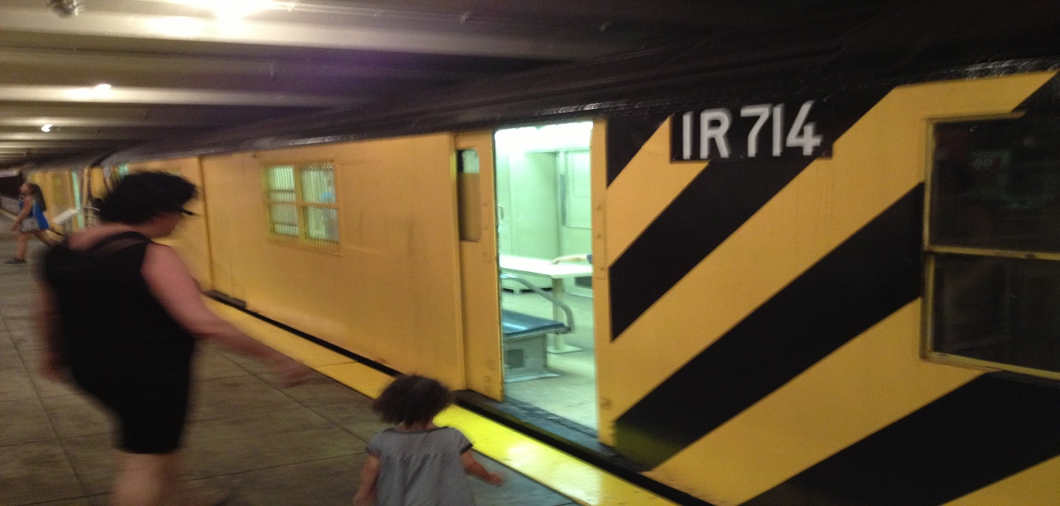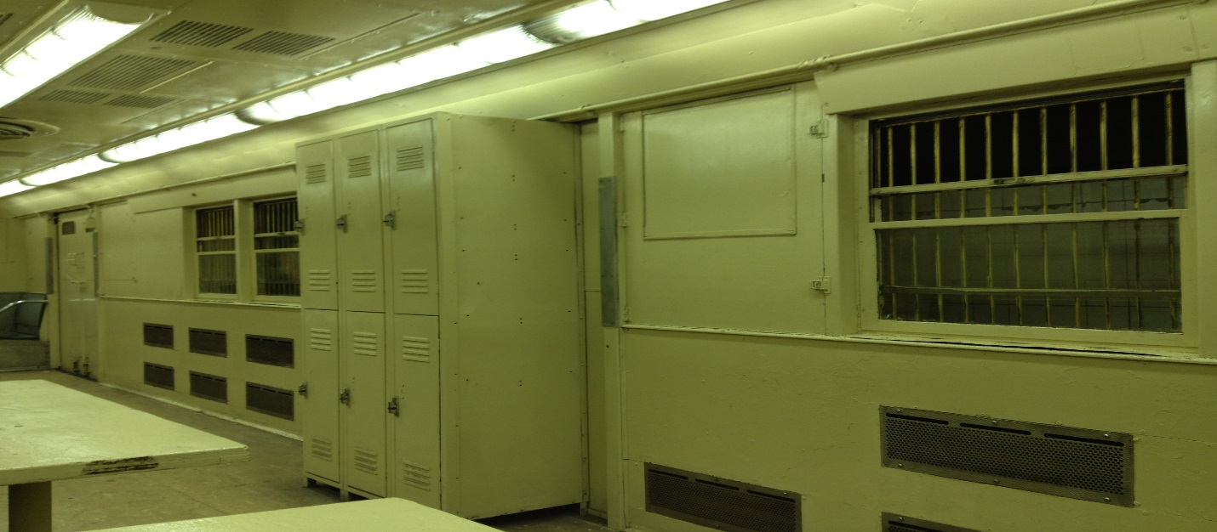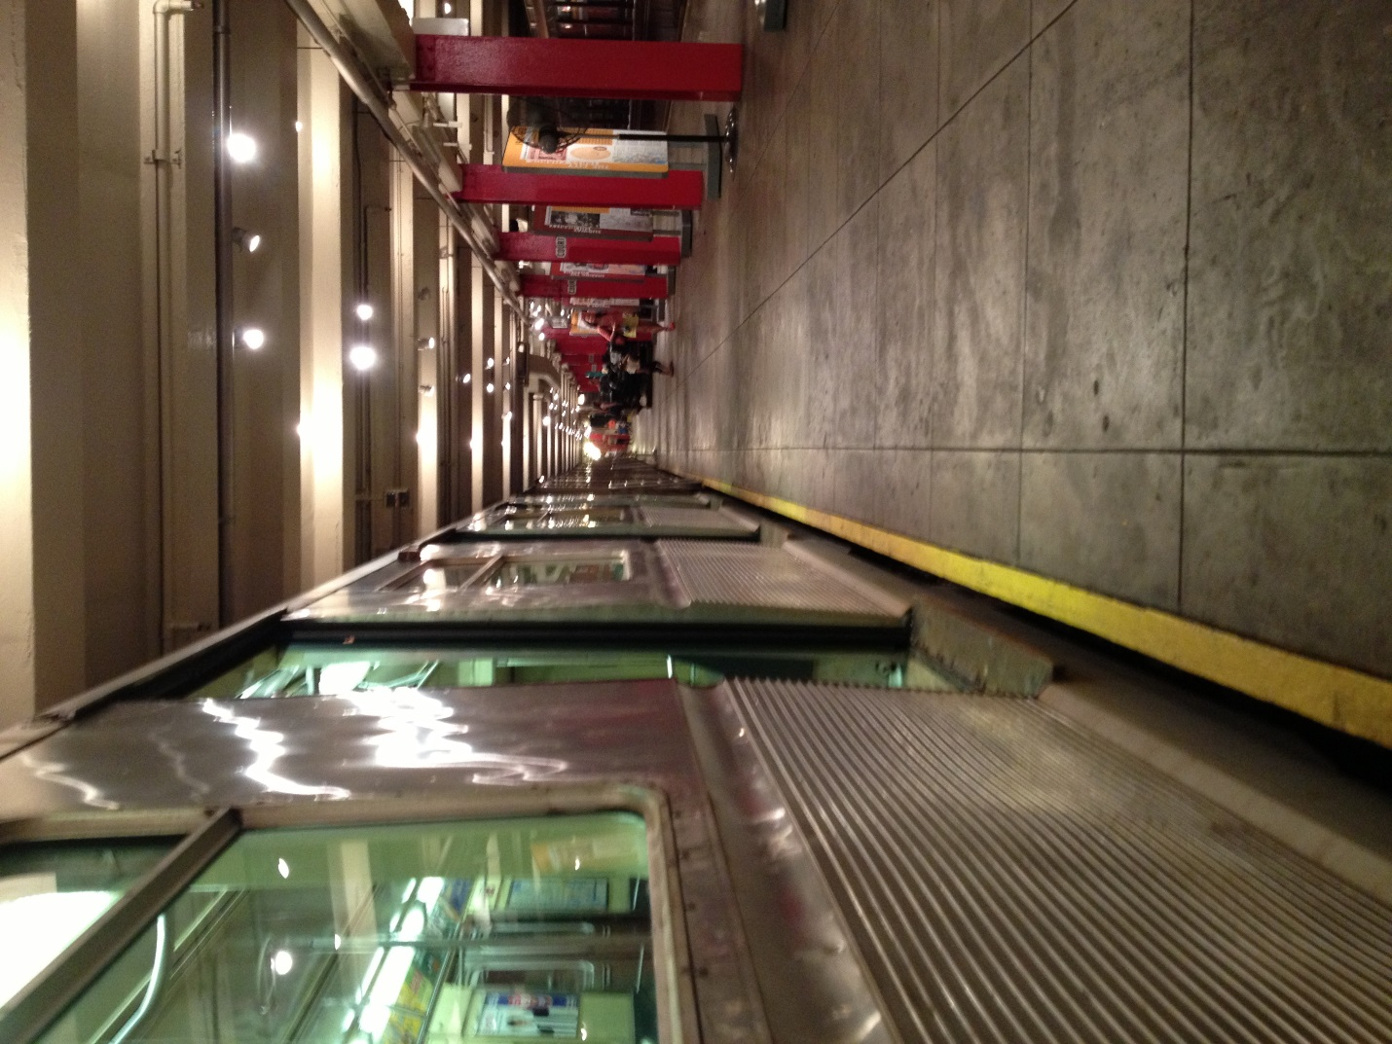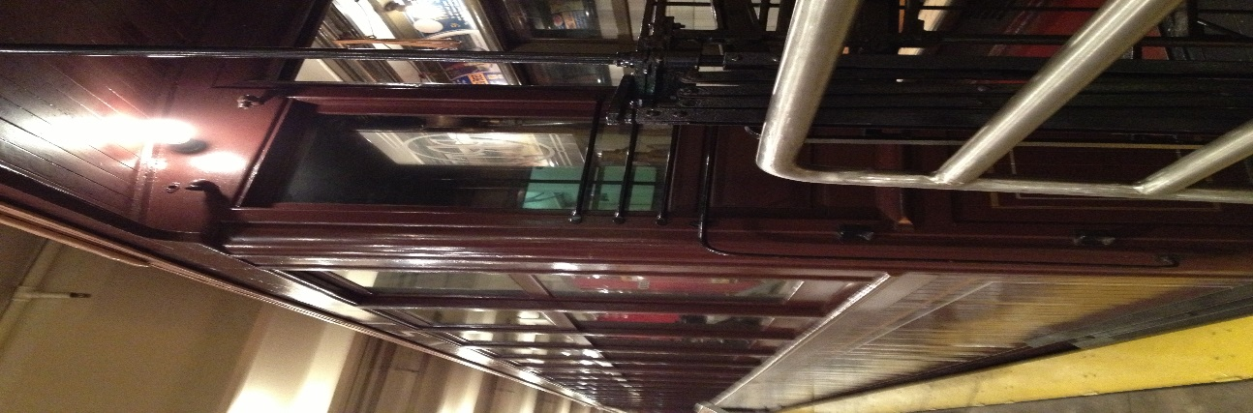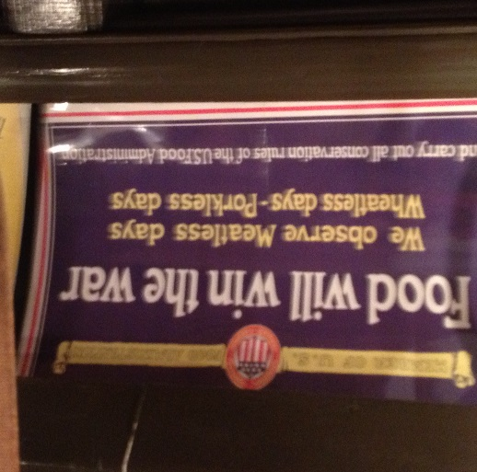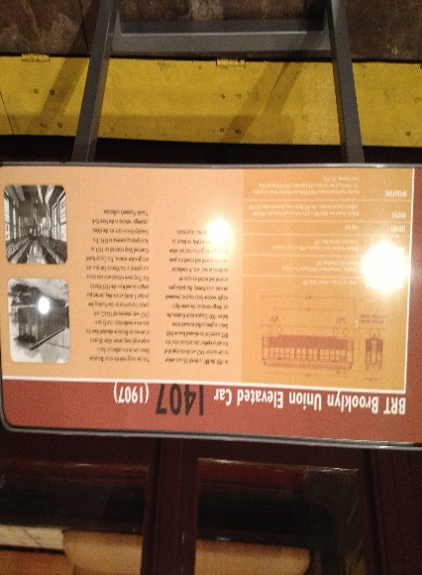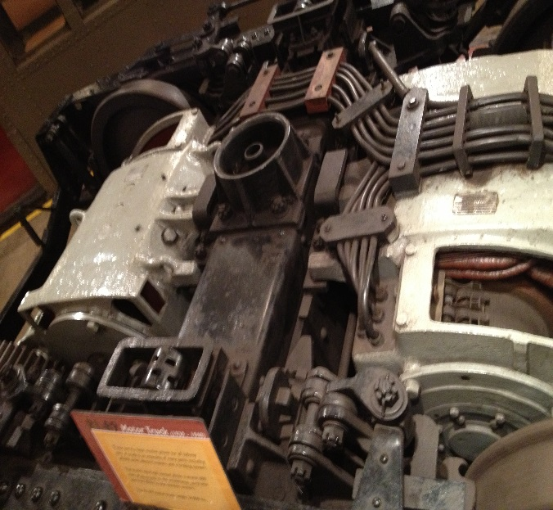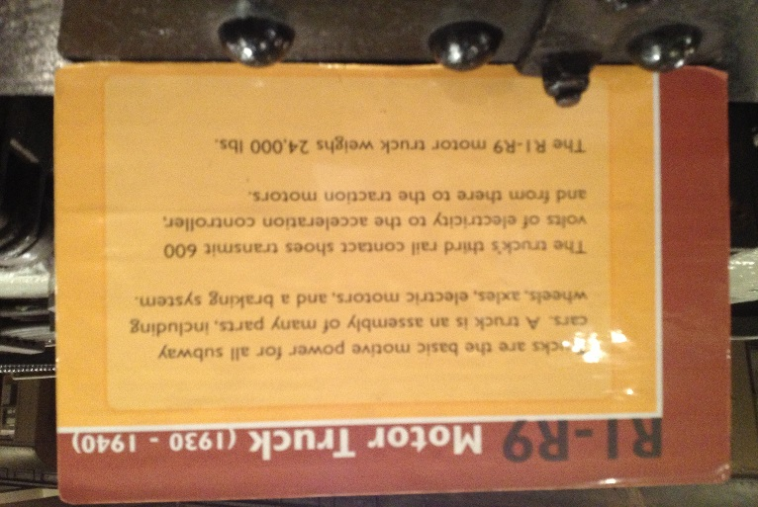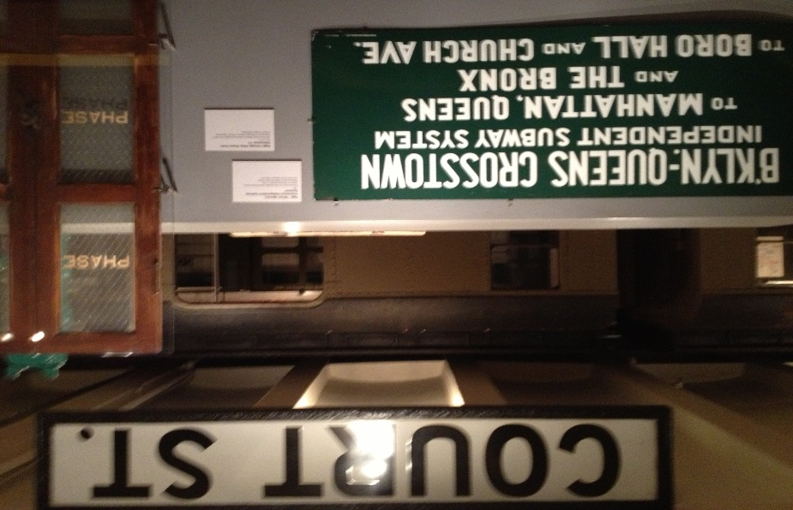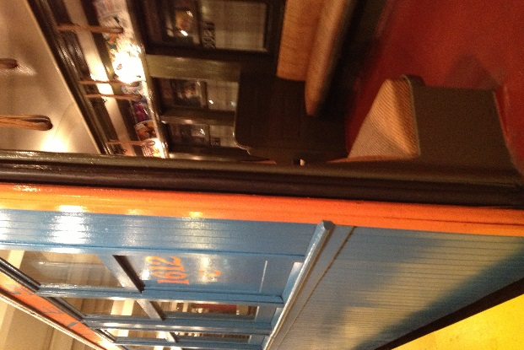Electric used to run the subway system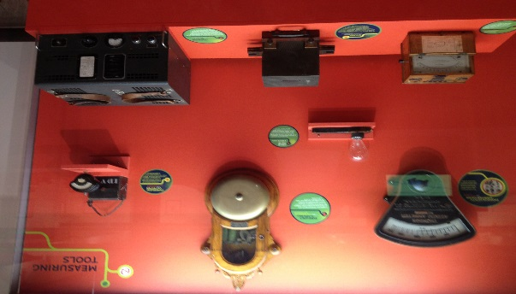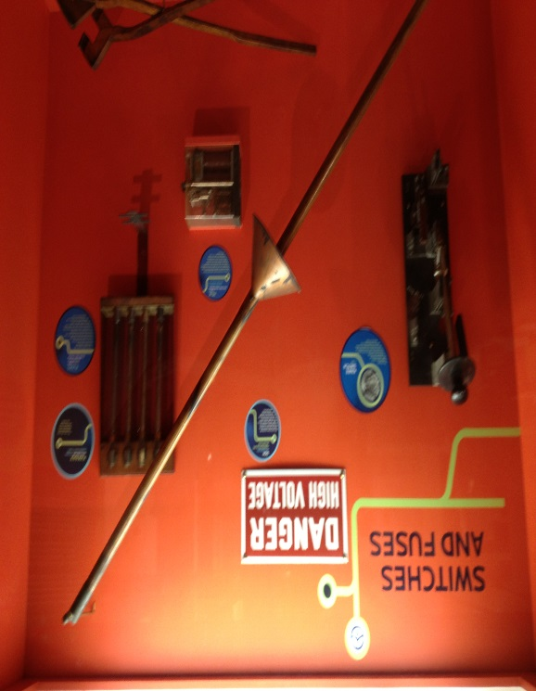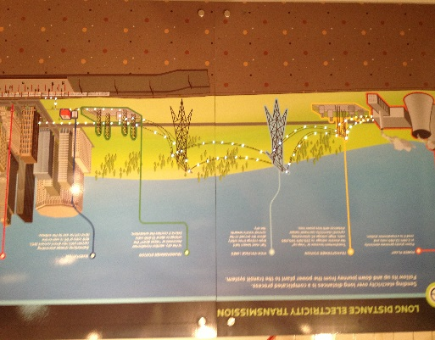
The highlight of the day was crossing over the Brooklyn Bridge. What more can be said about it? The sandhogs were the ones to place the tall pillars below the rivers bed: some developed Caissons Disease. John Roebling designed the bridge; unfortunately he passed away before the first stone was placed. His son, Colonel Washington Roebling continued his father’s dream until he developed Caissons Disease. His wife, Emily Roebling helped to finish the dream that both the father and son envisioned.
The Brooklyn Bridge was the first suspension bridge built. The Verrazano Bridge, built 1964 was the longest suspension bridge until Tsing Ma, Hong Kong was built in 1997 (Blue Guide). Today the Akashi Kaikyo, built in Hyogo, Japan in 1998, at 6,529 feet long: holds the rein of the longest suspension bridge to date.
